**ASSIGNMENT 3- BACKEND API DEVELOPMENT WITH DRF**

**Group-9 (Sachin Gaurav Srivastava, Shiva Krishna K, Avijit Nandi)**

___________________________________________________________________________

Code:

* + Code is available in github repo: <https://github.com/avijitn1/railman_django>

**App UI:**

RailMan App is a food catering service app for Indian Railways. The app is designed for both users and Restaurant administrator with different set of features based on the roles. The Main UI has navigation bar with various menu items.

* **Home**:

* **Layout elements**:
  + Navbar
  + Content
  + Footer
* **NavBar** consists of Menus:

Home, login, Signup, About, Services, Menu and Contact.



* **About**:

* **Order**:

* **Contact**:

* **Footer**:

**App Backend:**

**RailMan** backend is implemented with Django Rest Framework. The project name is Railman_backend. The project contains an app **railman.** Virtual environment **venv** is created and packages installed as required. Database used in sqlite3 for ease of use and portability.

**Model:**

ER diagram of the model is depicted below. The backend has 5 models: User, RestaurantOwner, Restaurant, Menu and Order.

Model.py

Admin access is created, and data is input as needed through Django admin page.

Serializers:

Model serializers are created to facilitate API responses:

**EPIC 1: Login and Registration:**

**1.1 Registration UI:**

The Signup component consists of:

1. Name/Organization field: [required]
2. Contact: [required, validated for 10-digit phone number]
3. Email: [required, validated]
4. Password: [required, validated – minimum 8-character, one uppercase, and numeric]
5. Confirm password: [required, validated matching password]
6. Role: User/Restaurant owner selection radio [default: user]

**Validation:**

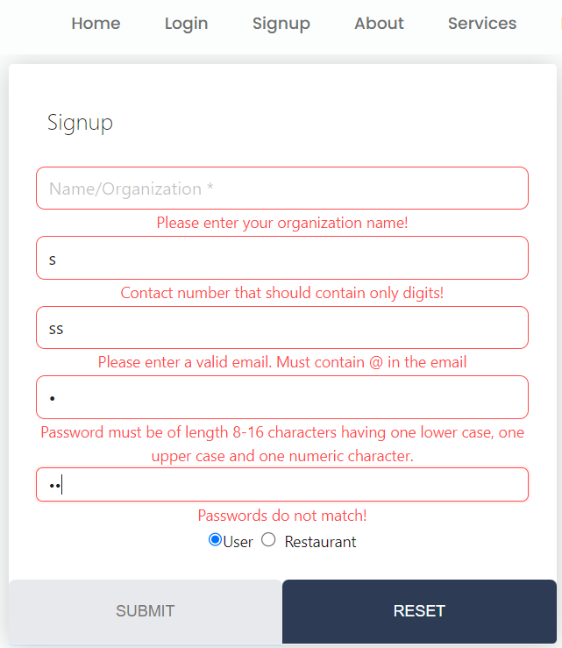

**Backend Implementation and integration with frontend:**

Rest APIs for Registration is implemented in views_authentication.py. The register API is handled as a POST request with essential fields as input.

On submit click user gets an alert “Successful registration”

Testing with Postman application:

**1.2 Login UI and Backend:**

On clicking Login menu Login UI is presented:

Integration with backend through DRF:

1. Correct credentials takes user to user dashboard.

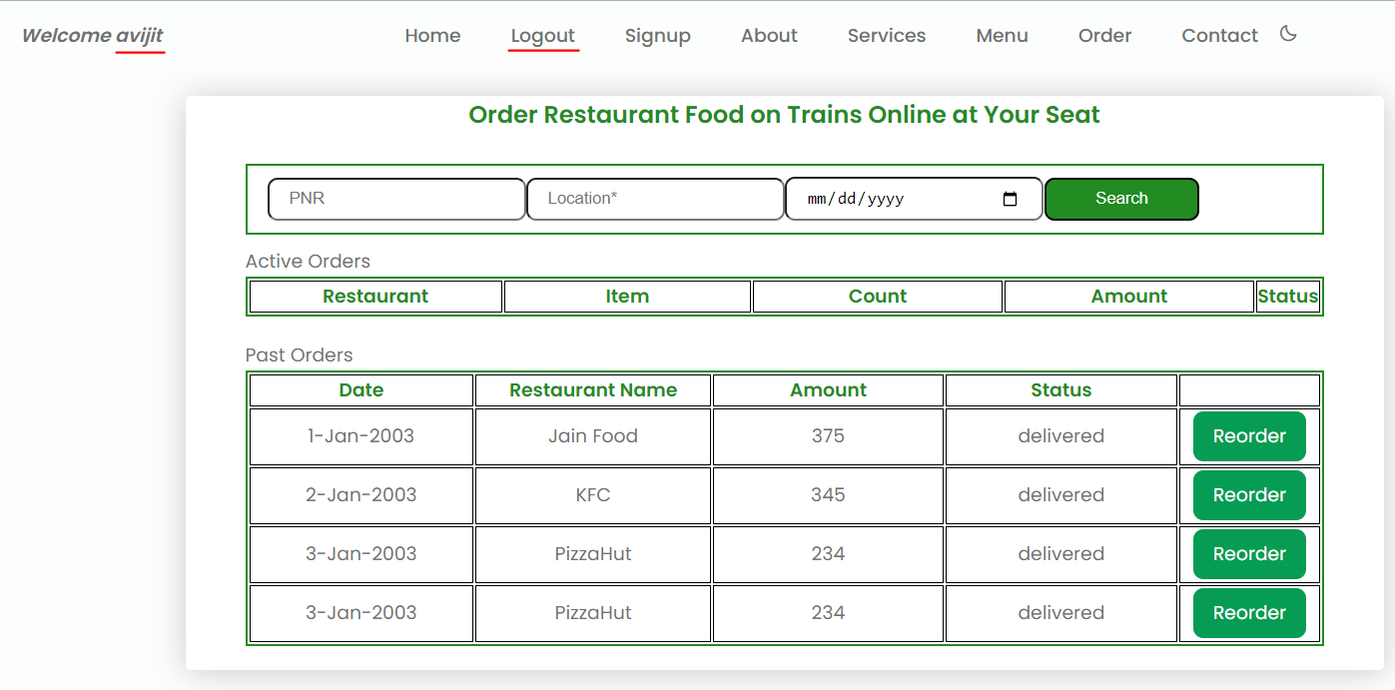

* 1. Restaurant owner to Restaurant owner dashboard.

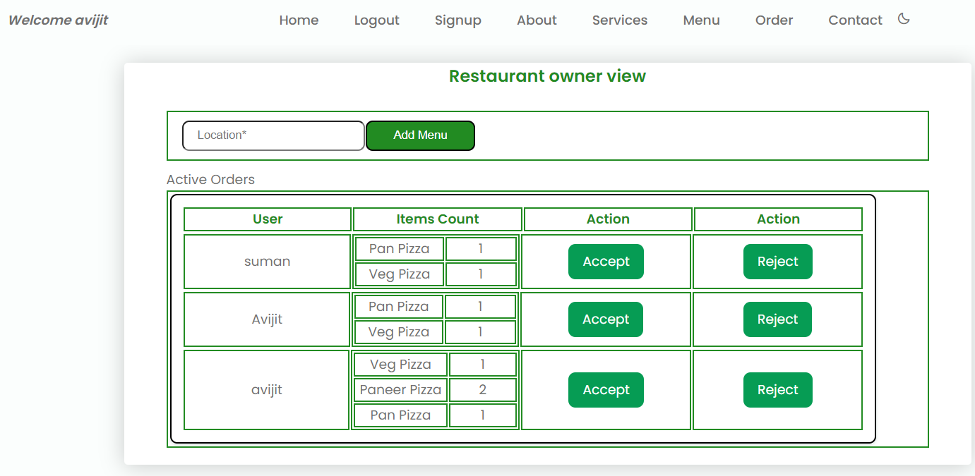

1. Correct credentials save data in Redux Store (Reducer: userData)
   1. NavBar menu updated to logout
   2. NavBar welcome message: “Welcome UserName”

**EPIC 2: CUSTOMER FOOD ORDER**

* 1. **User DashBoard:**

1. On Successful login user is presented with User Dashboard: No current order displays empty active orders table.

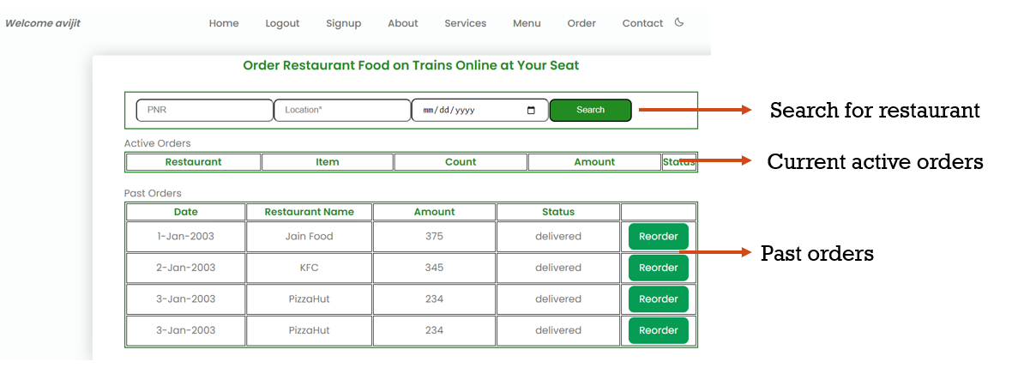

* 1. **View Restaurant:** 
     1. Search with PNR, Location (Station Name), Date



* + 1. OnClick Search button takes to Restaurant exploration page. Displays only restaurant matching search criteria. Multiple pages are displayed with 3 restaurants in each page.

Backend API Implementation: path('api/restaurants/city/', views.RestaurantList.as_view()),

Integration with Frontend:

* 1. **Select Item and Order**

**Backend API to explore Menu:** path('api/menu/', views.MenuList.as_view()),

1. Onclick Cart button on any Restaurant takes user to the Restaurant’s Menu page Example: We clicked on PizzaHut cart button:

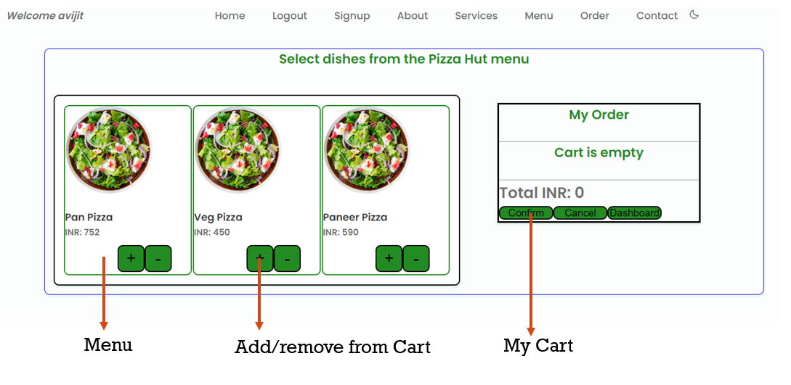

* + 1. OnClick Add to Cart button  the menu is added to the cart. My Order component shows all selected items and calculates total price of the items. This uses redux store to store data and show in main user dashboard

* + 1. OnClick => confirm button saves the order in the database and takes user to main user dashboard

**Redux State:**

Redux actions and Reducers are implemented to create state for each user.

* **State before login:**

* **State after login:**

* **State after adding to cart:**

**EPIC 3: RESTAURANT DASHBOARD**

3.1 **Restaurant Dashboard:**

Login with Restaurant role take user to Restaurant owner dashboard:

**Edit Menu**

On successful login Restaurant owner’s dashboard is presented with Navigation menu to **Edit menu**. Restaurant owner also get to see a dashboard to accept or reject orders.

Edit Menu items:

Update Menu API: path('api/menu/', views.MenuList.as_view()),

Updating price of Menu from INR 987 to INR 1000

Integration with Frontend:

Dashboard to Accept/reject orders:

Backend API for getting orders: path('api/orders/', views.OrderList.as_view()),

Documentation:

path(r'docs/', include_docs_urls(title='Helpdesk API')),

